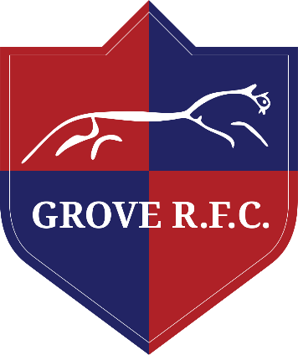

GROVE RUGBY FOOTBALL CLUB is committed to ensuring that equity is incorporated across all aspects of its development. In doing so it acknowledges and adopts the following Sport England definition of sports equity:

Sports equity is about fairness in sport, equality of access, recognising inequalities and taking steps to address them. It is about changing the culture and structure of sport to ensure it becomes equally accessible to everyone in society.

The club respects the rights, dignity and worth of every person and will treat everyone equally within the context of the sport, regardless of age, ability, gender, race, ethnicity, religious belief, sexuality or social/economic status.

The club is committed to everyone having the right to enjoy their sport in an environment free from threat of intimidation, harassment and abuse.

All club members have a responsibility to oppose discriminatory behaviour and promote equality of opportunity.

The club will deal with any incidence of discriminatory behaviour seriously, according to club disciplinary procedures.

Signed: Martin T Stalder

Date: 13/01/21019

